

Software Requirements Specification for online Pet Shop

Documented Releases

|  |  |  |
| --- | --- | --- |
| Revision Number | Revision Description | Revision Date |
| 1.0 | Main requirements | 17-04-2016 |
| 2.0 | Mockups formatting | 20-04-2016 |
| 3.0 | Document formatting final | 22-04-2016 |
|  |  |  |
|  |  |  |
|  |  |  |

Referenced Documents:

Table of Contents

**1.** **Introduction** 3

1.1 Purpose 3

1.2 Scope 3

1.3 Definitions 3

1.4 Overview 3

**2.** **Overall description** 4

**3.** **Graphical User Interfaces (mockups)** 4

3.1 Home Page 4

3.2 Sign In 5

3.3 Log In 5

3.4 User’s Profile 6

3.5 Product Page (Dogs, Cats, Birds, etc.) 6

3.6 Product description 7

3.7 Basket 7

**4.** **Flowchart Diagrams** 8

4.1 Administrator Flowchart 8

4.2 Customer Flowchart 9

**5.** **System description** 10

**5.1 Interfaces** 10

**5.2 Roles** 11

**5.3 Specific Requirements** 13

**6.** **Uses cases** 16

# 

# **1.** **Introduction**

## 1.1 Purpose

Defining and describing the functions and specifications of the Online Pet Shop (OPS) is the primary goal of this Software Requirements Specification (SRS). This Software Requirements Specification illustrates, in clear terms, the system’s primary uses and required functionality.

## 1.2 Scope

The system should allow customers to display catalogue based on brand name. It will create a shopping account for each customer and can manage multiple settings to edit account. Customers can select items from the catalogue and add it to a shopping cart. They can also delete items from the cart. Each time a customer adds or delete an item in the shopping cart, the system will display the updated cart content to the customer with the current total price. After customers’ finish shopping, they can check out the content of the shopping cart. An order will be created and presented to the customer. Customer might simply discard a shopping cart by never checking it out.

The Company needs to run a daily statistic report to show all completed orders and discarded carts.

## 1.3 Definitions

OPS- Online Pet Shop

SRS- Software Requirements Specification

GUI- Graphical User Interface

Stockholder- The person who will participate in system

Ex. User, Administrator, Customer

## 1.4 Overview

The rest of this document contains the overall description of the Online Pet Shop system and the specific requirements for the system.

# **2.** **Overall description**

The Online Pet Shop (OPS) application enables vendors to set up online shops, customers to browse through the shops, and a system administrator to approve and reject requests for new shops and maintain lists of shop categories. Also the developers are designing an online shopping site to manage the items in the shop and also help customers purchase them online without having to visit the shop physically. The online shopping system will use the Internet as the sole method for selling goods to its consumers.

# **3.** **Graphical User Interfaces (mockups)**

## Home Page

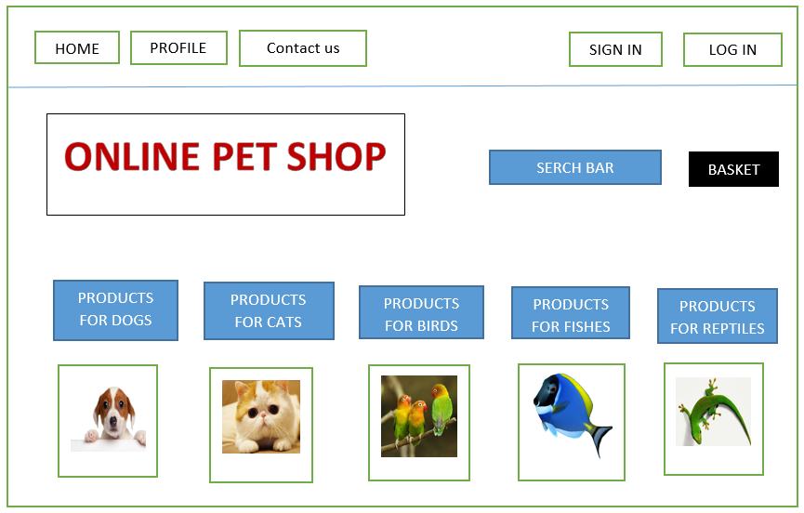

## Sign In

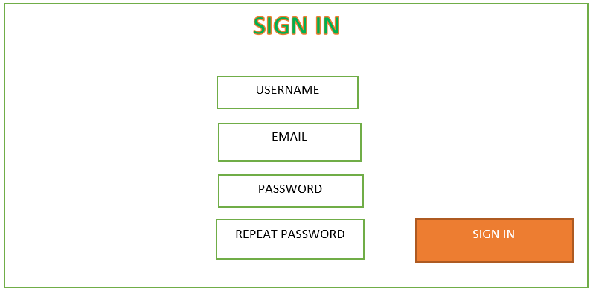

## Log In

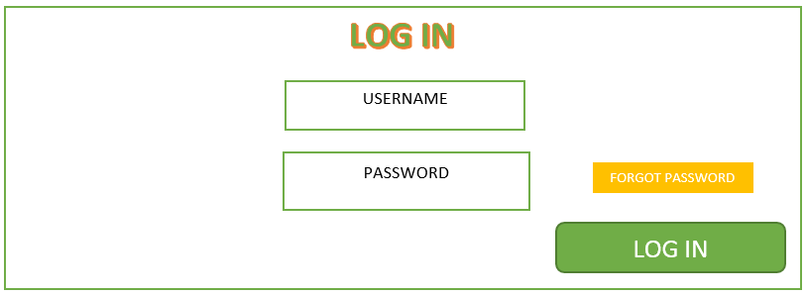

## User’s Profile

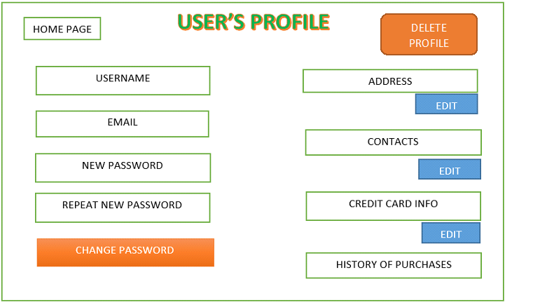

## Product Page (Dogs, Cats, Birds, etc.)

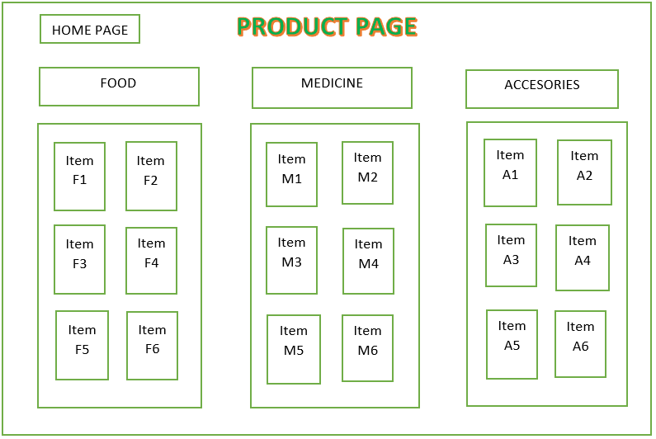

## Product description

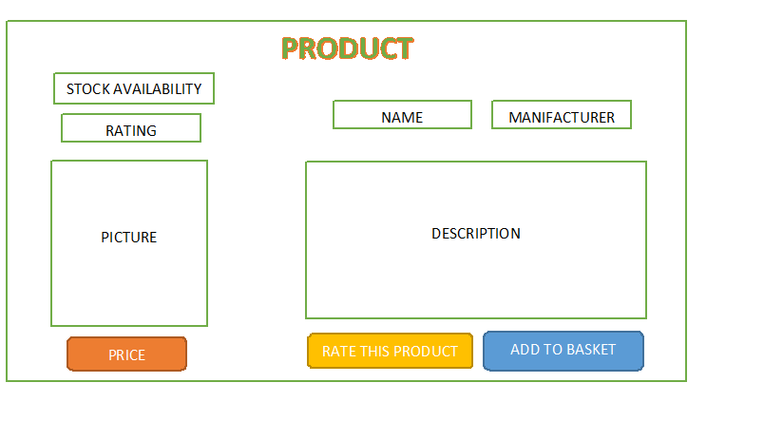

## Basket

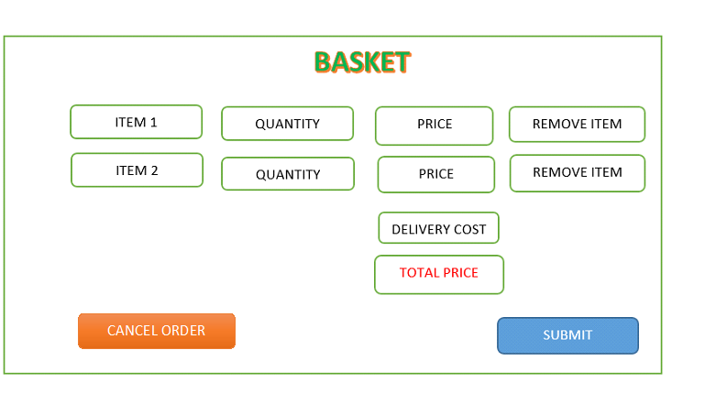

# **4.** **Flowchart Diagrams**

## Administrator Flowchart

LOG OUT

ADMINISTRATOR

USERNAME

LOG IN

PASSWORD

DELETE ORDER

VIEW ORDER

DELETE / BLOCK USER

VIEW USER

ADD USER

UPDATE PRODUCT

SEARCH PRODUCTS

DELETE PRODUCTS

ADD PRODUCTS

MANAGE ORDERS

MANAGE USERS

MANAGE PRODUCTS

## Customer Flowchart

LOG IN AS USER

REGISTER AS USER

REMOVE ITEMS

SUBMIT ORDER

EDIT PROFILE

INSERT CREDIT CARD INFORMATION

INSERT DELIVERY INFORMATION

DELETE PROFILE

CANCEL ORDER

NEW CUSTOMER

VIEW PRODUCTS

SEARCH PRODUCTS BY NAME

ADD TO BASKET

USERNAME

EMAIL

PASSWORD

LOG OUT

RATE PRODUCT

CHANGE PASSWORD

# **5.** **System description**

The system after careful analysis has been identified to be presented with the following Roles and Interfaces.

## **5.1 Interfaces**

The system will have two external interfaces: for a credit card verification and for order shipping.

* **Credit card authorization interface.**

The credit card authorization system will be used to accept and verify a customer's credit card information.

The information supplied in this screen will be sent directly to a credit card verification company, with secure site uses encryption technology. The Credit Card Input Screen will be displayed repeatedly with a prompt to re-enter the information in case of a credit card rejection.

* **Shipping system.**

The shipping system will be used to select a shipping method and to confirm the customer's shipping address and will be connected directly to a shipping company.

Once a payment has been accepted, the goods or services can be delivered in the following ways. For physical items:

- Shipping: The product is shipped to a customer-designated address. Retail package delivery is typically done by the public postal system or a retail courier such as BG Post, DHL, or EKONT.

- Drop shipping: The order is passed to the distributor, who then ships the item directly to the consumer, bypassing the retailer's physical location to save time, money, and space.

- In-store pick-up: The customer selects a local store using a locator software and picks up the delivered product at the selected location. This is the method often used in the bricks and clicks business model.

* **Shopping cart systems**

Simple shopping cart systems allow the off-line administration of products and categories. The shop is then generated as HTML files and graphics that can be uploaded to a web-space. The systems do not use an online database

## **5.2 Roles**

The roles involved are:

- Administrator

- Customer (Guest)

- User

* **Administrator:**

The administrator is the super user of this application. Only admin have access into this admin page. Admin may be the owner of the shop. The administrator has all the information about all the users and about all products.

This module is divided into different sub - modules.

- Manage Products

- Manage Customers

- Manage Orders

* **Manage product**
* Add Products

The shopping cart project contains different kind of products. The products can be classified into different categories by name. Admin can add new products into the existing system with all its details including an image.

* Delete Products

Administrator can delete the products based on the stock of that particular product.

* Search products

Admin will have a list view of all the existing products. He can also search for a particular product by name

* **Manage Customer**
* View Customer

The admin will have a list view of all the users registered in the system. Admin can view all the details of each user in the list except password.

* Add Users

Admin has privileges to add a user directly by providing the details.

* Delete & Block Users

Administrator has a right to delete or block a user.

* **Manage Orders**
* View Visitor

Administrator can view the Orders which is generated by the visitors.

He can verify the details of the purchase.

* Delete order

Admin can delete order from the orders list when the product is taken for delivery

* **Visitor:**

Visitors can only look at the items. They should log in as user to buy items.

* **Customers:**
* Registration

A new user will have to register in the system by providing essential details in order to purchase the products in the system. The admin must accept a new user by unblocking him.

* Login

A user must login with his user name and password to the system after registration, and any fallow time when he want to buy a product.

* View Products

User can view the list of products based on their names even he not logged in. A detailed description of a particular product with product name, products details, product image and price can be viewed by users.

* Search Product

Users can search for a particular product in the list by name.

* Add to cart:

The user can add the desired product into his cart by clicking add to cart option on the product only after he’s logged in. He can view his cart by clicking on the cart button. All products added by cart can be viewed in the cart. User can remove an item from the cart by clicking on remove button.

* Submit Cart:

After confirming the items in the cart the user can submit the cart by providing a delivery address. On successful submitting the cart will become empty.

* History

In the history the user will have a view of pending orders.

* Edit Profile

The user can view and edit their own profile.

## **5.3 Specific Requirements**

* Restrictions
  + User Side
    - Software
      * Any web browser
    - Hardware
      * Any device with operating system
  + System Side
    - Software
      * Web - based application
      * Database information storage system
* Data Structure
  + Products have these attributes
    - Unique ID (auto-incremented starting at 1, present only in the database tables) - Integer
    - Name – String [3-30]
    - Manufacturer – String [3-30]
    - Price – [Decimal]
    - Stock availability (when the number of available pieces of the item drops to 0, the item should be made unavailable for sale) - Integer
    - Description – [Text]
    - Rating – [Integer]
    - Photo of the item [Binary file]
  + Users has these attributes
    - Unique ID (auto-incremented starting at 1, present only in the database tables) – Integer
    - Unique Username – String [3-30]
    - Password – String [6-30]
    - Email Address - String [8-30]
    - Address – String [8-30]
    - History of all orders made by the user
  + Admin has these attributes
    - Username - String [3-30]
    - Password - String [3-30]
    - List of all banned users
    - List of all deleted users
  + Order log entries have these attributes:
    - Unique ID (auto-incremented starting at 1, present only in the database tables) – Integer
    - Time and date of the transaction - DateTime
    - User’s primary details
    - Listing of the contents in user’s shopping basket
* System
  + Browse Inventory
    - Organization
      * Products Listed on single page
      * Products shown in tabular format
      * Each Product listing contains
        + Name – String [3-30]
        + Producer - String [3-30]
        + Price - Decimal
        + Availability - Integer
        + Price - Decimal
  + Search Inventory
    - Search available only by name of product or manufacturer
    - Search is exact-match only
  + Create, Update and Destroy (CRUD) Functionality
    - Only admins are allowed to modify inventory
    - Admins have an interface to:
      * Create an item entry
      * Update an item entry
      * Update the stock/quantity of a particular item
    - Administrator may delete items from the inventory
  + Shopping Basket
    - Logged In
      * Can add items to cart
        + If Item is not in stock, message displayed informing user to try again later
      * If shopping cart not empty, a user may begin Checkout procedure
    - Not Logged In
      * Can add items to cart
      * Customer required to login as user before they may begin Checkout procedure
  + Checkout procedure
    - User must successfully use shopping basket before beginning this procedure
    - Checkout page consists of
      * An overview of the purchase
      * A button to complete the order
    - Order details sent via email after the checkout has completed
    - On order completion the inventory is decremented based on items purchased by user

# **6.** **Uses cases**

*Use Case №1:* Create account  
*Primary Actor*: Customer  
*Pre Condition*: Installed browser and active Internet connection   
*Main scenario*:

1. Customer initiates the browser
2. Customer specifies web address for accessing the OnlinePetShop
3. Customer enters Registration Module
4. Customer register with valid username, email and password
5. Customer becomes a registered user after receiving email with confirmation

*Negative scenario:*  
 1 Registration fails – required information fields were not entered  
 1.1 System prompt the guest to fill necessary fields

2 Registration fails – username / email already exist in database

2.1 System requires another username / email to continue with registration

*Use Case №2:* Login  
*Primary Actor*: User / Admin  
*Pre Condition*: One must be registered as user / admin  
*Main scenario*:

1. One enter “Sign in” section, situated on main menu bar
2. Enter (username or email) and password
3. System does authentication
4. Welcome page is displayed

*Negative scenario:*  
 1 Authorization fails – wrong username/password  
 1.1 Prompt the user that the username/password is typed wrong  
 1.2 System allow to re-enter the username/password  
 2 Authorization fails – forgotten username/password  
 2.1 Prompt the user to enter registered email  
 2.2 User receives an email with instructions about his login credentials

*Use Case №3*: Change password  
*Primary Actor*: User  
*Pre Condition*: User logged in   
*Main scenario*:

1. User goes to OnlinePetShop.Navigate to “Profile” menu
2. User initiates “Change Password” functionality
3. User provides current password, new password and confirm new password
4. System displays message for successful change

*Negative scenario:*  
 1 Authorization fails – wrong password  
 1.1 Prompt the user that he typed the password wrong  
 1.2 Allow him to re-enter the password  
 2 Authorization fails – new password and confirm new password do not match  
 2.1 Prompt the user that new password and confirm new password do not match  
 2.2 Allow him to re-enter the attributes.  
 3 Authorization fails – new password and confirm password are less than 6 chars  
 3.1 Prompt the user that password must be at least 6 characters  
 3.2 Allow him to re-enter new and confirm password

*Use Case №4*: Add product to system  
*Primary Actor*: Admin  
*Pre Condition*: Admin logged in   
*Main scenario*:

1. Admin goes to Add Product section
2. Admin clicks Add product button
3. Admin enters valid data, at least in the required fields
4. Product is added to the system and database

*Negative scenario:*  
 1 Admin does not fill data in the required fields

* 1. Admin is prompted to fill the required fields

2 A product with the exact same data already exists

2.1 Admin is prompted to fill other data

*Use Case №5*: Update product  
*Primary Actor*: Admin  
*Pre Condition*: Admin logged in   
*Main scenario*:

1. Admin goes to Update product section
2. Admin clicks Update product button
3. Admin finds product by name or finds it among all of them
4. Admin changes product’s details
5. Product’s data is updated

*Negative scenario:*  
 1 Admin enters product’s name that does not exist

1.1 Admin is prompted to enter another product name

2 Admin enters invalid data

2.1 Admin is prompted to enter valid data

3 Admin deletes necessary data from required fields

*Use Case №6*: Delete product  
*Primary Actor*: Admin  
*Pre Condition*: Admin logged in   
*Main scenario*:

1. Admin goes to Delete product section
2. Admin clicks Delete product button
3. Admin finds product by name or finds it among all of them
4. Admin deletes product
5. Product is removed from the system and the database

*Negative scenario:*  
 1 Admin enters product’s name that does not exist

2 Admin enters invalid data

3 Admin deletes data from required fields

*Use Case №7:* Add product to basket

*Primary Actor:* Customer/ User

*Pre-Condition:* Customer not logged in/ User logged in

*Main scenario:*

1. Navigate to the web page
2. Go to products catalog or enter product’s name in search box
3. Click add product to basket or click on the product to view details and then click add product to basket
4. Product is added to basket

*Negative scenario:*

1. Product not found by name

1.1 An appropriate message saying “There is no such product” is shown

1. Customer has not been registered yet. Should be prompted to register

*Use Case №8:* Remove product to basket

*Primary Actor:* Customer/ User

*Pre-Condition:* Customer not logged in/ User logged in

*Main scenario:*

1. Navigate to the web page
2. Go to customer/user basket
3. Choose particular product
4. A remove from basket button should appear
5. Click remove button
6. Product is removed from basket

*Use Case №9:* Search product

*Primary Actor:* User/Admin

*Pre-Condition:* User/Admin logged in

*Main scenario:*

1. Navigate to the web page
2. Type name in the search bar
3. Click search button or press enter
4. Searched product/s should be shown, or message saying “There is no such product” should appear

*Negative scenario:*

1. User enters invalid symbols in the search bar
2. When enter is pressed something else happen, rather than pressing the search button

*Use Case №10:* Block user

*Primary Actor:* Admin

*Pre-Condition:* Admin logged in

*Main scenario:*

1. Navigate to the web page
2. Go to Admin specific functions
3. Click block user/s button
4. Type username or choose user from list of users
5. Click block user button
6. User is blocked and removed from the list with active users

*Use Case №11:* Delete user

*Primary Actor:* Admin

*Pre-Condition:* Admin logged in

*Main scenario:*

1. Navigate to the web page
2. Go to Admin specific functions
3. Click delete user/s button
4. Type username or choose user from list of users
5. Click delete user button
6. User is deleted and removed from the list with active users and from database

*Use Case №12:* Submit order

*Primary Actor:* Customer/User

*Pre-Condition:* Customer not logged in/User logged in

*Main scenario:*

1. Navigate to the web page
2. Navigate to basket
3. Click submit order button
4. Confirmation page should be shown
5. Click confirm button

*Negative scenario:*

1. Customer has not been registered yet
   1. Should be prompted to register

*Use Case №13:* Rate product

*Primary Actor:* User

*Pre-Condition:* User logged in

*Main scenario:*

1. Navigate to the web page
2. Navigate to some product that the user has ordered
3. Choose rating (from 1 to 6)
4. Click add rating

*Negative scenario:*

1. User manipulates front-end and adds an invalid rating
   1. Rating should be validate in the business logic layer and in the database layer

*Use Case №14:* Cancel order

*Primary Actor:* User

*Pre-Condition:* User logged in

*Main scenario:*

1. Navigate to the web page
2. Navigate to make submit an order page
3. Click cancel order button
4. Order should be cancelled